**LED FLASHER**

CIRCUIT DIAGRAM

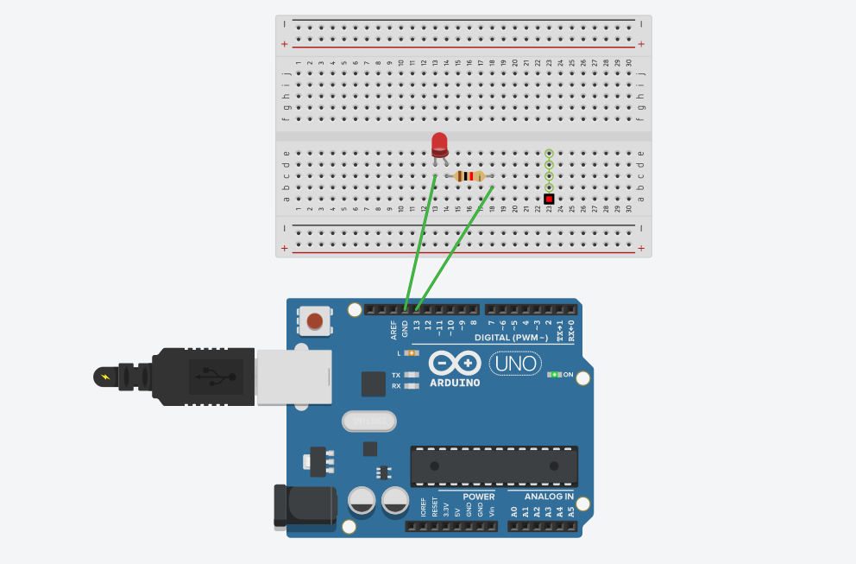

CONCEPT USED:

We know that “LED” stands for light emitting diode, which glows when the current is provided to it so to make an “LED” blink we have to turn off and turn on the current power supply. Doing it manually will be a lot of headache (if we have to make it blink continuously).

We use Arduino to do such work for us.

By writing a code for Arduino to perform the blinking of “LED”.

Use of knowledge of coding (loop: for loop).

Knowledge of Arduino software.

Knowledge of positive - negative terminal of “LED”, circuits, Breadboard.

Learning & Observations:

1: Arduino can output 5v while connected to pc with powercord.

2: Arduino has three ground pins.

3: Arduino have both Digital and Analog pins.

4: Digital pins are for OUTPUT and INPUT both.

5: Analog pins are only for INPIUT only.

Problems & Troubleshooting:

1: Wrong Board selection in Arduino program.(select Arduino uno in board selection menu )

2: Used wrong pin while coding(write correct pin while coding).

Precautions:

1: Choose correct board in arduino software.

2: Code properly otherwise the led won’t glow or it might not blink.

3: Connect the circuit properly and correctly.

4: don’t forget to connect Arduino to computer.

Learning Outcomes:

1: How to blink and led using Arduino.

2: Proper use of loop.

3: Where is positive and negative terminal of “LED”.

4: How breadboard works.

5: How Arduino works.